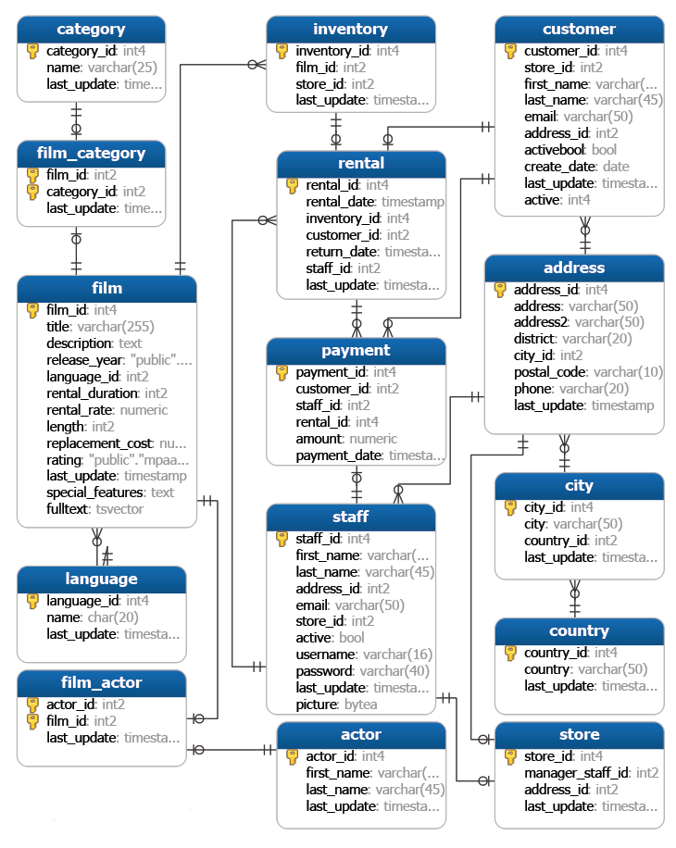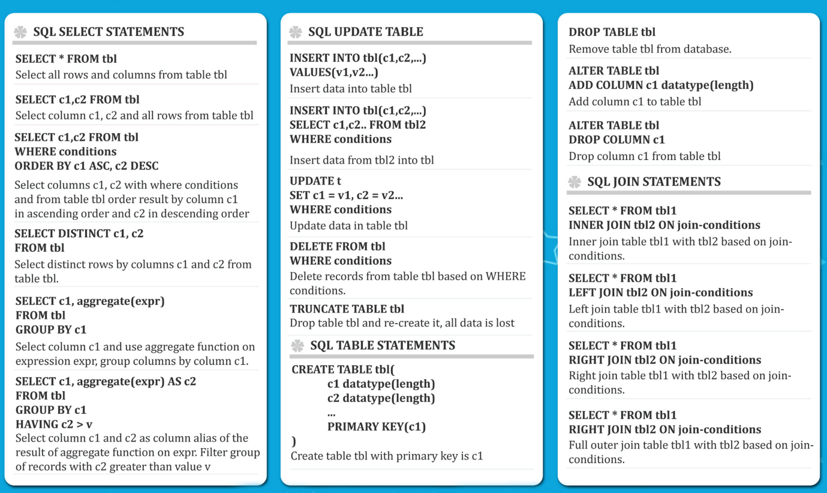

Assessment Test 1

**ASSESSMENT TEST 1**

**COMPLETE THE FOLLOWING TASKS!**

1. Return the customer IDs of customers who have spent at least $110 with the staff member who has an ID of 2.

The answer should be customers 187 and 148.

2. How many films begin with the letter J?

The answer should be 20.

3. What customer has the highest customer ID number whose name starts **with** an 'E' **and**has an address ID lower than 500?

The answer is Eddie Tomlin

Solutions to Assessment Test 1

**SOLUTIONS TO ASSESSMENT TEST 1**

**1. Solution Below:**

SELECT customer_id,SUM(amount)

FROM payment

WHERE staff_id = 2

GROUP BY customer_id

HAVING SUM(amount) > 110;

**2. Solution Below:**

SELECT COUNT(*) FROM film

WHERE title LIKE 'J%';

**3. Solution Below:**

SELECT first_name,last_name FROM customer

WHERE first_name LIKE 'E%'

AND address_id <500

ORDER BY customer_id DESC

LIMIT 1;

Quick Note on TO_CHAR

This is a note in regards to the next lecture, we've gotten a lot of questions of why TO_CHAR "doesn't work" for one of the assessment questions. It actually does work, but you need to realize certain codes are "blank padded to 9 characters", which means instead of returning 'Monday' it returns 'Monday   ' with extra spaces to fill up at least 9 spaces.

Source:

<https://www.postgresql.org/docs/12/functions-formatting.html>